Cameron JENKINS

NEW COLLEGE LANARKSHIRE

HND WEB DESIGN AND DEVELOPMENT

Nav Map, moodboard and wireframes

TASK 3

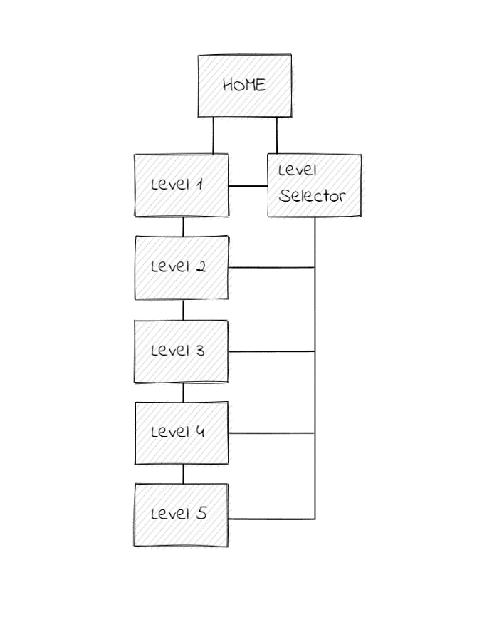**Nav Map:**

Since my game is very simple in design it only requires a home page and pages for the levels. Each level has access to the home page and the level selector while on the page if the user wants to quickly jump to a different game.

**Wireframes:**

**Start Page**

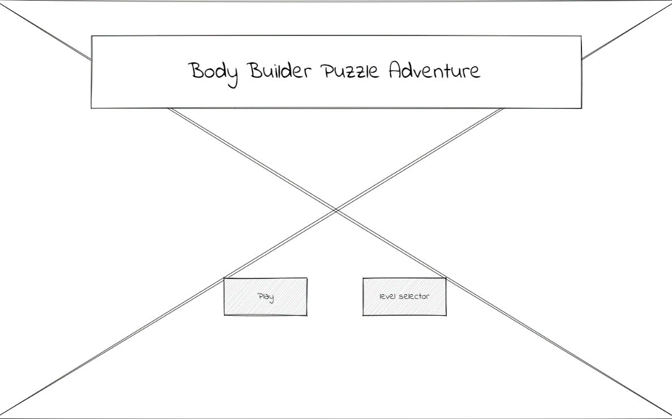

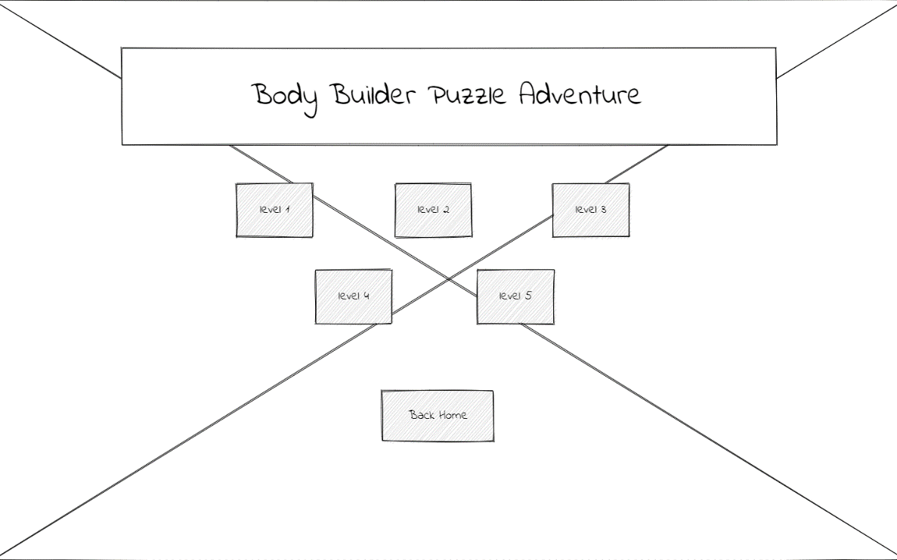**Level Selector**

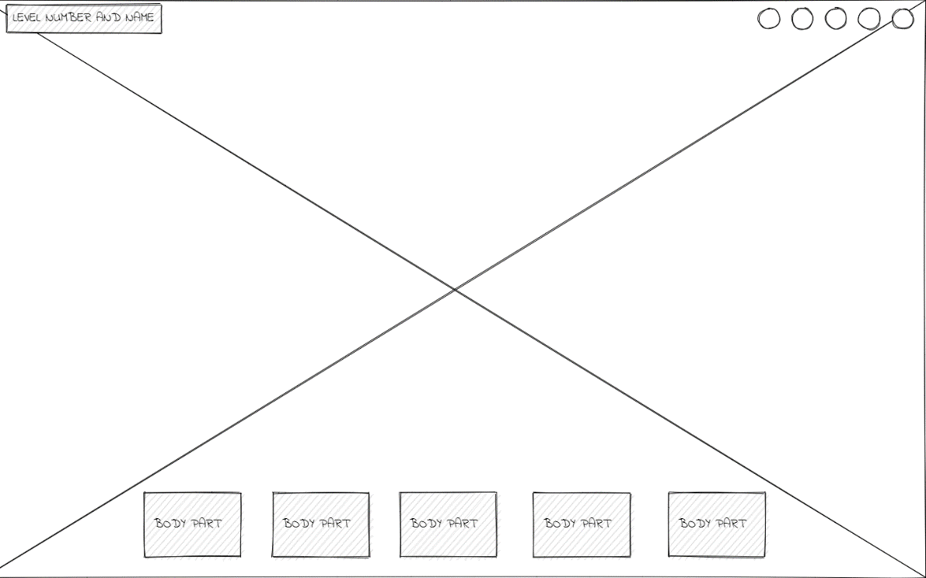**Level Layout**

**Moodboard:**

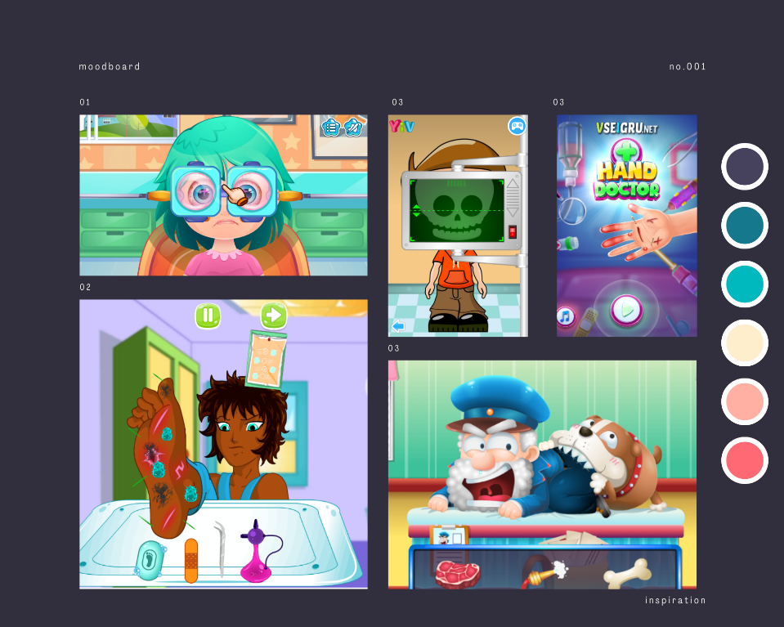

Tried getting some images of similar games but for some reason they’re all weirdly graphic, THIS WILL NOT BE LIKE THE GAME. However, it does convey the same drag and drop theme that I will be going for.